**Step Two:**

Cloning your repository to your PC (for most folks, this is really your Windows VDI)

Most folks will begin with their current source code converted from **Clear Case** into the Stash server by the RPS team.

In the examples that follow, I am using the ‘**qr_unix’** repository. The principles are the same as long your repository ends in **‘_unix**’.

Connect to the stash server web interface using this address in your browser:

<https://borg.plaza.ds.adp.com:8443/projects>

Don’t forget to log in. Use your everyday login credentials for username and password. After you log in, stash presents a page with projects. Read this page carefully and find the repository (repo) you want to work on. You must clone a repo to work on it.

This example will use the Drive Enterprise Reporting project.

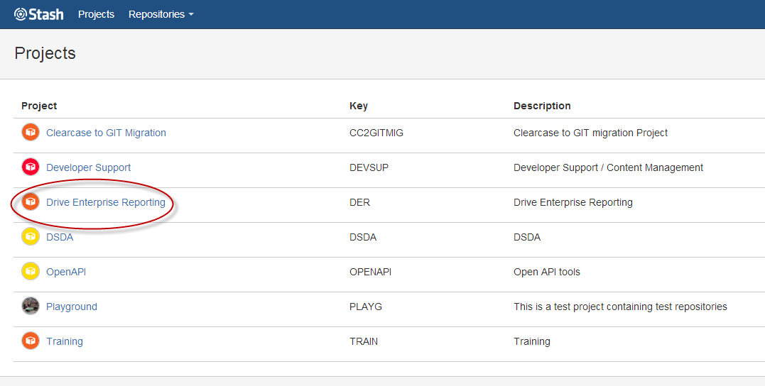

These repositories are in the Drive Enterprise Reporting project:

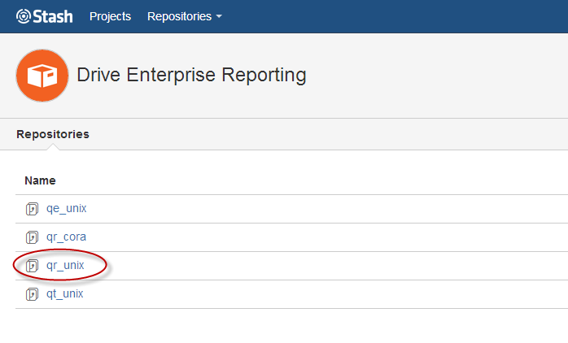

The repo we want to clone is qr_unix.

Here we are in our web browser, looking at the stash server for our repo:

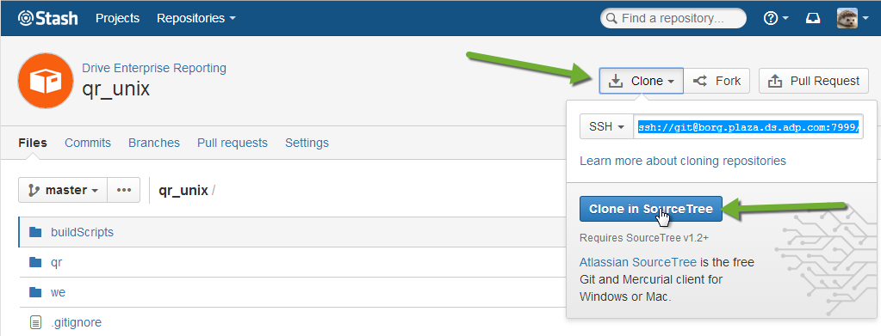

If you are having trouble getting to this screen, be sure that you are logged in! Stash will log you out when you are inactive. Time flies when you are having fun, and learning new stuff is fun, isn’t it?

You should have set up an SSH key when you installed git. Look for Git GUI on your Windows Start program menu if you need to set up an SSH key. You do want an SSH key. Trust me.

The two steps here are

1. Press the ‘**Clone**’ button
2. Then press the ‘**Clone in Source Tree**’ button.

You may see this External Protocol Request dialog. Click Launch Application.

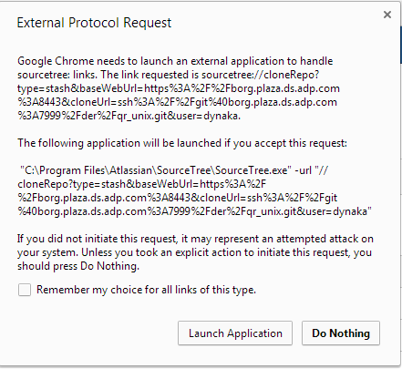

Pressing of the ‘**Clone in Source Tree**’ button in the web browser launches **Source Tree** and shows us a dialog the looks like this.

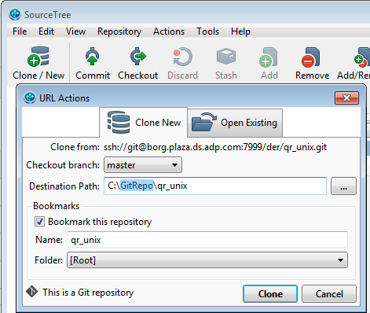

The text for the ‘Destination Path’ normally defaults to something in your C:\users\... directory. I happen to prefer keeping all my GIT repositories in my C:\GitRepo directory. **Press the ‘Clone’ button** once you have decided the whole ‘Destination Path’ issue. The default path is fine, too.

Accept the other setting in this dialog is is.sourcetree17934

Once the cloning is done, you can see your repository in **Source Tree**.

Take your time to explore the many tabs and clickable links on this page. The screen shot below is from the Log / History tab.



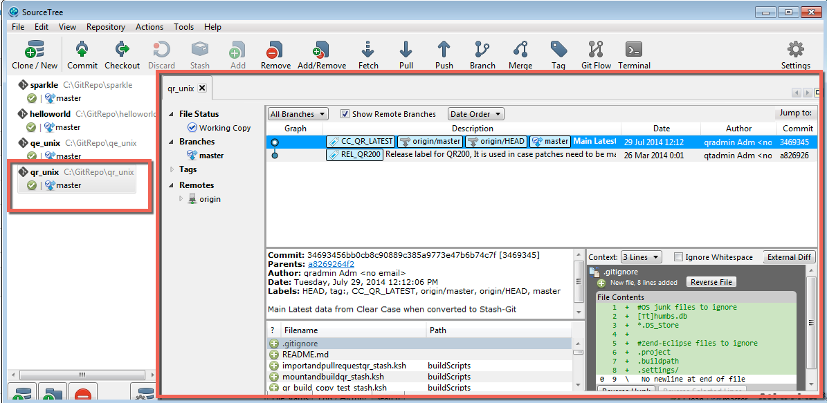

Step two is done. Congratulations! You have a local GIT repository on your PC/VDI.